Practical - 7
Practical Title: 7: PHP Form Processing with Server-Side Validation and CSV/JSON File Storage

Problem Definition: Process submitted registration/contact form data using PHP. Validate and sanitize inputs on the server side and store records in CSV or JSON file

format. Display success/error messages.

A. Theory
1. Is the form submitted using POST?
ANSWER:
Yes. The form should use the POST method so that the submitted data is sent securely in the request body rather than being exposed in the URL.

2. Are inputs validated and sanitized server side?
ANSWER:
Yes. PHP should validate the submitted data on the server, such as checking required fields, email format, password rules, and other input requirements. Sanitization should also be performed to reduce unwanted or unsafe characters.

3. Is file writing handled safely?
ANSWER:
Yes. The PHP program should open/create the CSV or JSON file safely, write the data in the correct format, and close the file properly. File locking can also be used while writing to prevent conflicts.

4. Are success and error responses displayed clearly?
ANSWER:
Yes. The application should display clear messages after form submission, such as a successful registration message or an appropriate error message when invalid data is entered.

Implementation/ Output/Result:

Evidence of Work (Screenshots):

The profile page:
Entering details of the user.
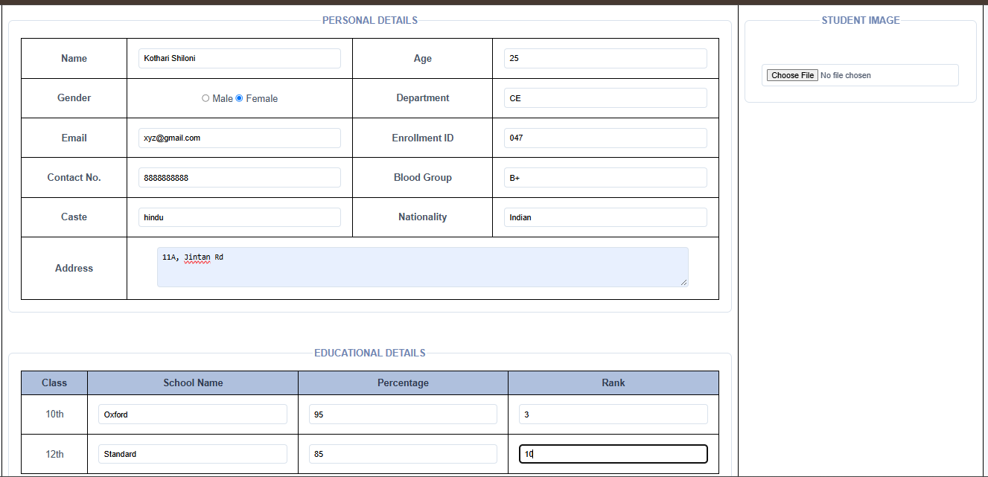

After entering the every details, the localhost displays “Profile Saved Successfully!”.
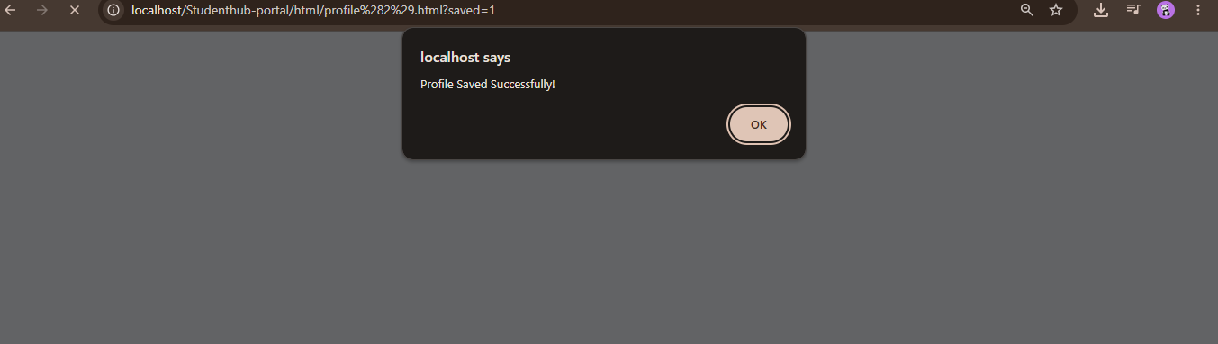

After saving the profile details of one user, it redirects to the profile page again.
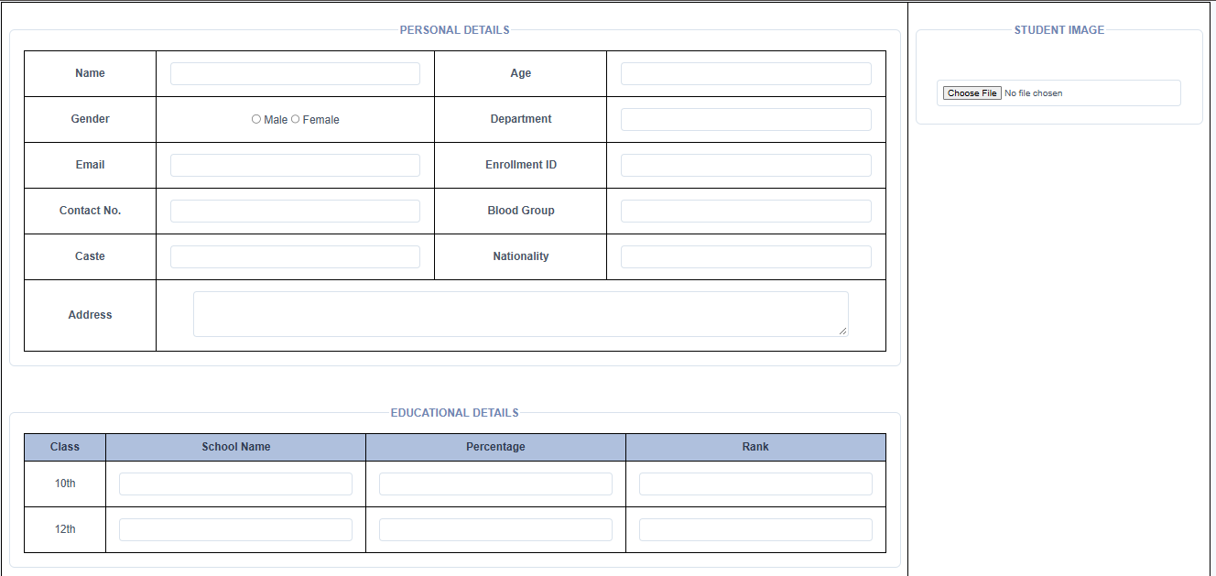

Entering another user details:
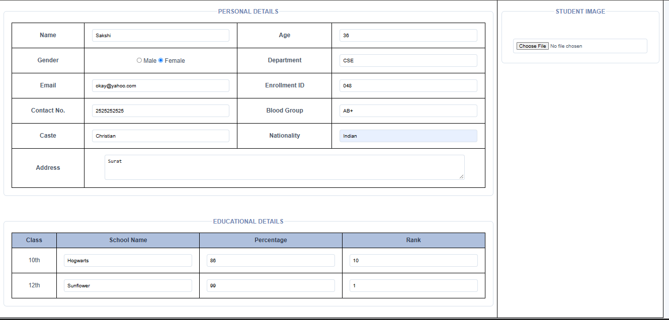

The data which is shown and saved in the excel (.csv) file:
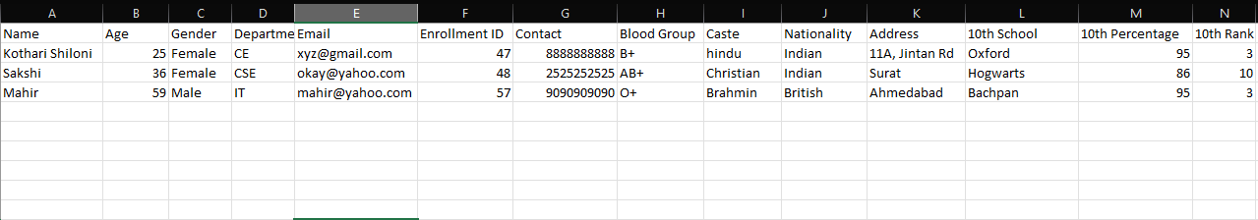
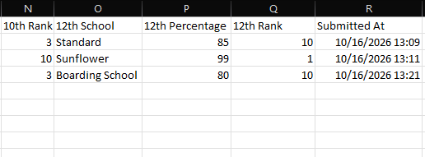

GitHub Repository Link:

https://github.com/shiloni28/WDF.git

E.Challenges Faced:

- After the profile was saved successfully the re-direction was not happening:
- It was showing error of URL not found.
- Then edited the path in the code so the error of re-direction was solved.

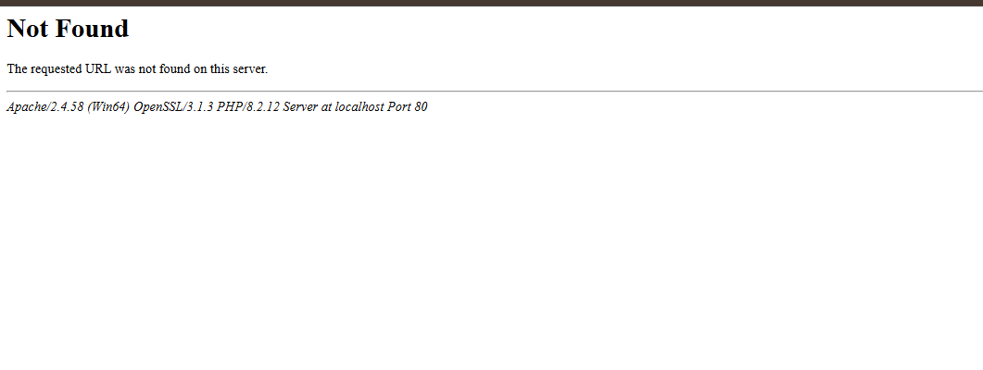

- Maintaining the correct structure and format of stored data.
- Debugging PHP errors while testing the form with XAMPP.
- To perform the server-side validation accurately.

F.Learning Outcomes:

- Using XAMPP and connecting PHP.
- Seeing the saved data into the .csv file.
- Re-direction after submitting the profile details.
- Create and process PHP forms and implemented in the profile page using the POST method.
- Perform server-side validation and sanitization of form inputs.
- Understand the importance of validating data before storing it.

Faculty Remarks:

